**Alaska OCS Energy**

To manage the development of the U.S. Outer Continental Shelf (OCS) energy, mineral, and geological resources in an environmentally and economically responsible way.

# Oil and Gas on the Alaska Outer Continental Shelf

There are 21 active oil and gas leases -- six leases in the Beaufort Sea and 15 in Cook Inlet -- on the Alaska OCS, encompassing approximately 103,565 acres. The Beaufort Sea leases include 3 leases in the Northstar Unit and 3 leases in the Liberty Unit. The Northstar unit, located on an artificial gravel island in state waters of the Beaufort Sea, has been producing since 2001 and overlays state and federal acreage. In the future, the operator may submit an amended development and production plan for the Liberty leases and resubmit an exploration plan for the Cook Inlet leases.

BOEM reviews plans to ensure that proposed activities conform to regulatory performance standards; comply with Federal laws, regulations, and lease terms; can be conducted safely; adhere to sound conservation practices; protect the rights of the U.S. Government; do not unreasonably interfere with other OCS uses; and do not cause undue harm to the human, marine, or coastal environments. More information on Alaska OCS oil and gas activities is available at: https://www.boem.gov/regions/alaska-ocs-region.

BOEM also provides a comprehensive national assessment of undiscovered oil and gas resources in five-year intervals for OCS areas, including the Alaska OCS. BOEM’s most recent National Assessment, the 2021 National Assessment of Undiscovered Oil and Gas Resources of the U.S. Outer Continental Shelf, is available at: https://www.boem.gov/oil-gas-energy/resource-evaluation/undiscovered-resources.

# Renewable Energy on the Alaska OCS

While there are currently no renewable energy leases on the Alaska OCS, BOEM remains actively involved in studies, outreach and engagement, and interagency coordination that can inform future planning efforts. In December 2023, BOEM established the Cook Inlet Work Group (CIWG) to meet with Federal and State agencies to discuss renewable energy efforts on a quarterly basis. Current discussions of the CIWG center around the potential for renewable energy on the Cook Inlet OCS.

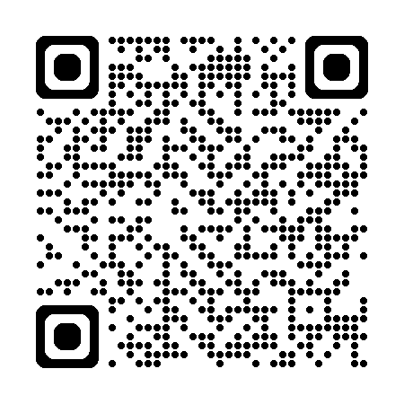The National Renewable Energy Laboratory’s (NREL) 2023 report to BOEM, titled “Feasibility Study for Renewable Energy Technologies in Alaska Offshore Waters,” analyzes how different renewable energy technologies could be used to potentially provide power to communities within Alaska. The NREL report discusses how the Alaska OCS has renewable resources (e.g., wind, wave, and tidal resources) for potential electricity generation. The report is available at: <https://espis.boem.gov/final%20reports/BOEM_2023-076.pdf>

*Access this  
document online*