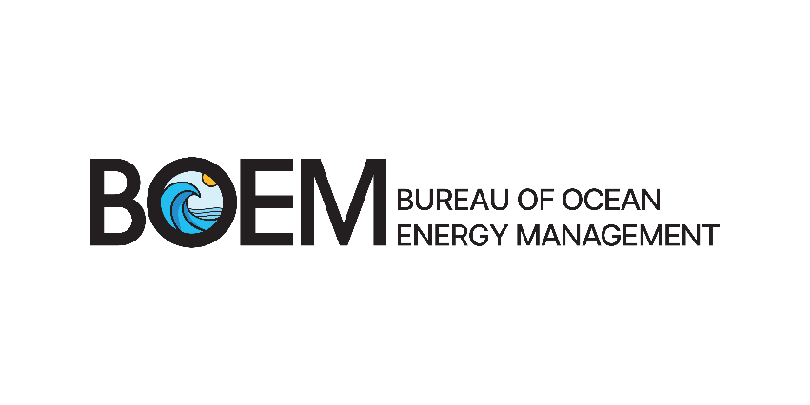
Environmental Studies Program
Science for Informed Decisions

The Bureau of Ocean Energy Management’s Environmental Studies Program develops, funds, and manages rigorous scientific research on marine, coastal, and human environments. BOEM uses science to inform policy decisions regarding Outer Continental Shelf (OCS) resource development. BOEM’s environmental studies cover a broad range of disciplines including physical oceanography, atmospheric sciences, biology, protected species, social sciences (including economics and submerged cultural resources), and the environmental impacts of energy and mineral development.
Since the ESP’s launch in 1973, it has funded more than $1.3 billion of research nationwide, with more than $465 million dedicated to research in coastal Alaska. ESP has produced more than 1,600 study reports and peer-reviewed publications related to Alaska. Access 50 years of BOEM Environmental Studies on GovInfo.
The information gained through BOEM’s ESP studies can benefit the following sectors related to Arctic and National Security:
Energy Security – We assess the feasibility and potential impacts of emerging energy technologies in Alaska. Example studies include:
- Feasibility Study for Renewable Energy Technologies in Alaska Offshore Waters. Assessed the feasibility of ocean-based renewable energy sources on the Alaska OCS.
- Yakutat Wave Energy Converter Impact Assessment. Collected Information to help assess the potential impacts from wave energy converters.
Food Security – We contribute foundational knowledge on the population abundance, population trends, and ecology of key commercial and subsistence species in Alaska and the Arctic. Example studies include:
- Satellite Tracking of Bowhead Whales. Described the migration and habitat use patterns of bowhead whales in the U.S. Arctic and how those patterns change with a warming environment.
- Essential Fish Habitat (EFH) Descriptions for Arctic Cod, Saffron Cod and Snow Crab in the Alaskan Arctic. Described the essential habitat of fish species in the U.S. Arctic.
Supply Chain/Transportation Security – Through in-depth research on sea ice dynamics and trends, we bolster knowledge about the transportation and shipping environment in the Arctic. Example studies include:
- Landfast Ice Climatology within the Arctic OCS. Created a 27-year picture of landfast sea ice on the Arctic OCS showing a substantial reduction in extent and duration.
- Development of a Very High-Resolution Regional Circulation Model of Beaufort Sea Nearshore Areas. Used a state-of-the-science ocean model to simulate at least a decade of the currents, sea ice, and winds in the Beaufort Sea nearshore areas.
Environmental Hazards – Our work on coastal dynamics illuminates threats posed to coastal areas and infrastructure, as well as possible mitigations. Example studies include:
- River Overflood on Sea Ice and Strudel Scour in the U.S. Beaufort Sea. Improved the understanding of overflood processes on the North Slope of Alaska and the related pipeline and facility siting hazards.
- Central Beaufort Sea Wave and Hydrodynamic Modeling Study. Assessed how reduced sea ice and changes in ocean and atmospheric conditions affect wave and storm surge conditions and coastal erosion rates.
Emergency Management – Our research on oil spills, oil-ice interactions, and the coastal operating environment improves emergency preparedness and response. Example studies include:
- Literature Study on Effects of Spills of 500–20,000 Barrels of Crude Oil, Condensate, or Diesel. Documented environmental and socioeconomic impacts from medium to large oil spills.
- The ShoreZone Program – This multi-agency program mapped and imaged the entire coastline of Alaska. The ESP funded protocol development, mapping the Alaska Peninsula region, and the North Slope region.

