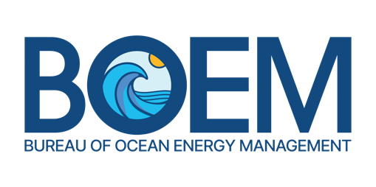

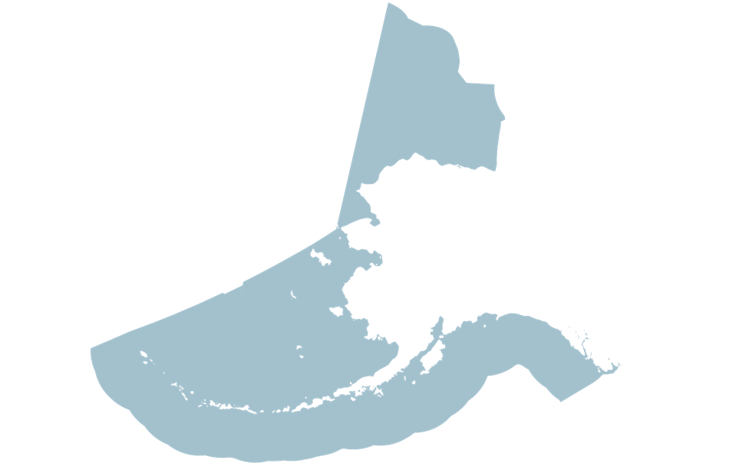
The Bureau of Ocean Energy Management is a federal agency within the U.S. Department of the Interior. Our mission is to manage the development of U.S. Outer Continental Shelf (OCS) energy, mineral, and geological resources in an environmentally and economically responsible way.

In Alaska, BOEM is responsible for overseeing the sustainable use of vast offshore resources beyond the State's three-mile coastal boundary, encompassing approximately 1.05 billion acres of federal waters.
Alaska
OCS Region

BOEM’s Alaska OCS Region is organized into three key program offices:

Office of Resource Evaluation: Uses geologic and geophysical data to assess the quantity and economic value of offshore oil, gas, and marine minerals.

Office of Leasing and Plans: Manages the leasing process for energy and mineral exploration and development, ensuring that plans comply with safety and environmental regulations.

Office of Environment: Provides critical scientific analysis and research to ensure that all offshore activities are conducted with minimal environmental impact. This office integrates Indigenous Knowledge and partners with local communities to safeguard cultural and ecological resources.
KEY AREAS OF FOCUS

Conventional Energy. Overseeing offshore oil and gas operations, currently managing 21 leases in Alaska’s federal waters.
Renewable Energy. Exploring the potential of offshore wind, tidal, and wave energy, with a focus on Cook Inlet, which is among the world's richest tidal power resources.
Marine Minerals. Regulating the extraction of marine minerals, such as sand, gold, cobalt, and lithium, crucial for economic and national security.
Carbon Sequestration. Developing regulatory frameworks to support carbon sequestration in offshore sub-seabed geological formations.

u Our Commitment to the Environment and Community. Since 1973, BOEM has invested more than $450 million in Alaska and Arctic research. We continue to fund studies that enhance our understanding of the marine environment. We prioritize collaboration with Alaska Native communities and stakeholders to ensure that Traditional Knowledge is integrated into our decision-making processes.

u Our Strategic Role. Aligned with the White House’s National Strategy for the Arctic Region, BOEM plays a pivotal role in securing national interests in the Arctic through sustainable development, environmental protection, and international cooperation.


u Engagement and Partnerships. BOEM actively collaborates with federal and state agencies, Alaska Native communities, industry, and non-governmental organizations to achieve shared goals. Through robust outreach and transparency, BOEM fosters trust and understanding among all stakeholders.

